Hypergraph Neural Networks

Introduction

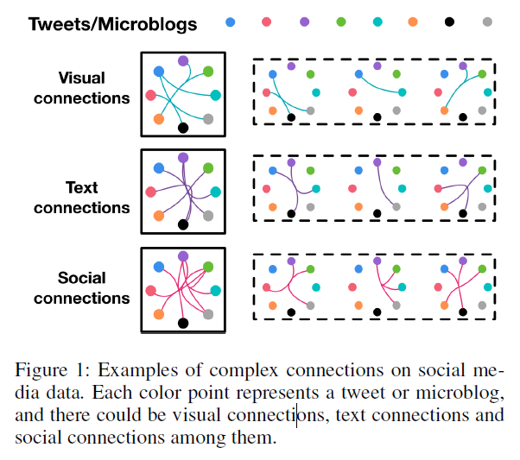

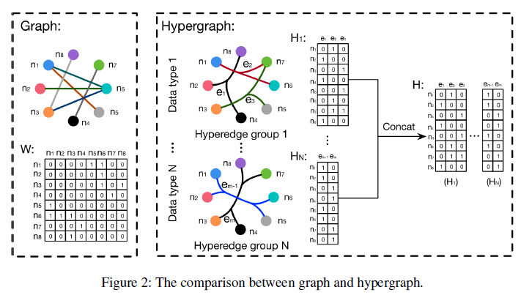

The main contributions of this paper are two-fold:

1. We propose a hypergraph neural networks framework, i.e., HGNN, for representation learning using hypergraph structure. HGNN is able to formulate complex and high-order data correlation through its hypergraph structure and can be also efficient using hyperedge convolution operations. It is effective on dealing with multi-modal data/features.

2. We have conducted extensive experiments on citation network classification and visual object classification tasks. Comparisons with state-of-the-art methods demonstrate the effectiveness of the proposed HGNN framework. Experiments also indicate the better performance of the proposed method when dealing with multi-modal data.

Related Work

Hypergraph learning

In many computer vision tasks, the hypergraph structure has been employed to model high-order correlation among data.

Neural networks on graph

Since many irregular data that do not own a grid-like structure can only be represented in the form of graph, extending neural networks to graph structure has attracted great attention from researchers.

For generalizing convolution network to graph, the methods are divided into spectral and non-spectral approaches.

For spectral approaches, the convolution operation is formulated in spectral domain of graph.

For spatial approaches, the convolution operation is defined in groups of spatial close nodes.

Hypergraph Neural Networks

Hypergraph learning statement

Different from simple graph, a hyperedge in a hypergraph connects two or more vertices.

Spectral convolution on hypergraph

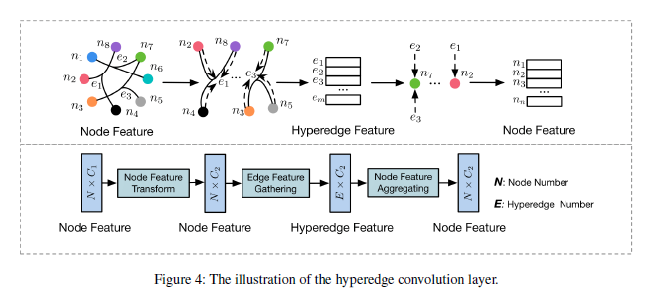

Hypergraph neural networks analysis

Relations to existing methods

Implementation

Hypergraph construction

Model for node classification

Experiments

In this section, we evaluate our proposed hypergraph neural networks on two task: citation network classification and visual object recognition.

Citation network classification

Visual object classification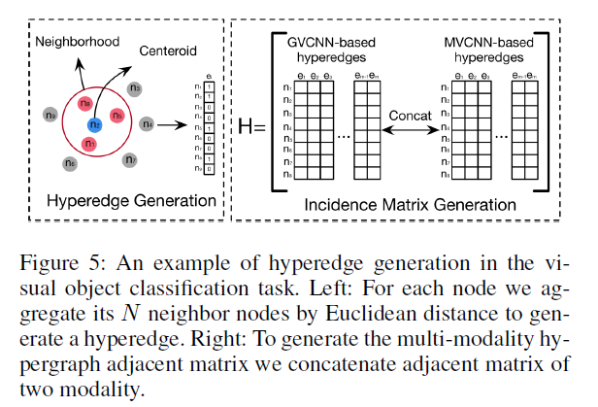

Hypergraph structure construction on visual datasets

Conclusion

In this paper, we propose a framework of hypergraph neural networks (HGNN). In this method, HGNN generalizes the convolution operation to the hypergraph learning process. The convolution on spectral domain is conducted with hypergraph Laplacian and further approximated by truncated chebyshev polynomials. HGNN is a more general framework which is able to handle the complex and high-order correlations through the hypergraph structure for representation learning compared with traditional graph. We have conducted experiments on citation network classification and visual object recognition tasks to evaluate the performance of the proposed HGNN method. Experimental results and comparisons with the state-of-the-art methods demonstrate better performance of the proposed HGNN model. HGNN is able to take complex data correlation into representation learning and thus lead to potential wide applications in many tasks, such as visual recognition, retrieval and data classification.